Click on AGENTS

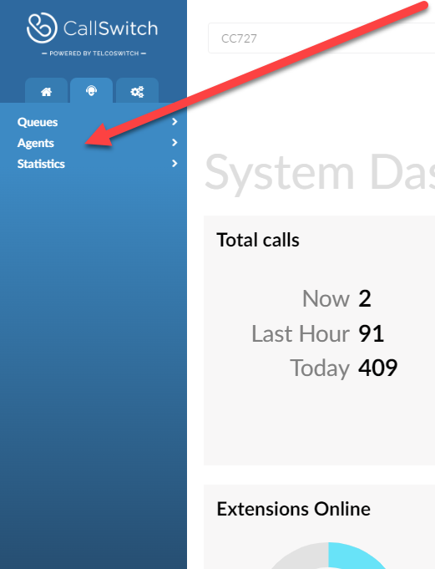
Then GROUPS
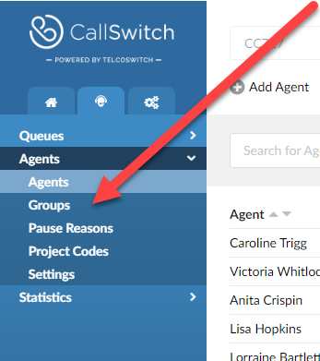
Click on the specific queue you want to add to
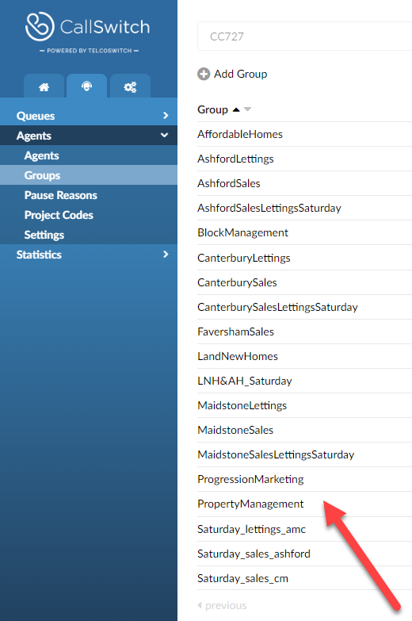

Click into the AGENTS box , add Agents from the drop down and SAVE

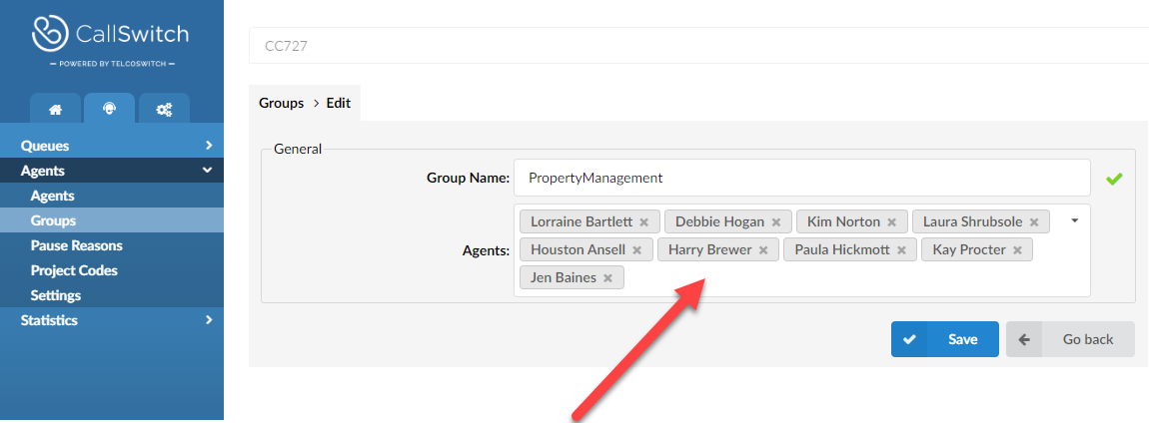to ADD Agents to Queue Groups

