CHAT can be accessed on the dashboard of the desktop version of Communicator and its one of the tabs on the mobile version
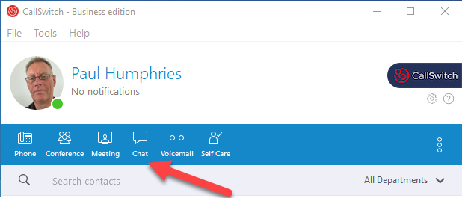

Click on the CHAT icon.
On the mobile version then click the + button and you can select the users / extensions that you want to CHAT with. Invite the user/extension and then just type message and send . If you click on the + button next to the message box you can add photos and documents to the CHAT.
On the desktop version just type the extension you want to CHAT with into the search box, click on the user and type the message and send .
With this the desktop version you can add files and emojis to the CHAT. If you click on the three dots to the right of the search box you get a number of additional functions . On the header you will see that you can move from CHAT directly to a telephone CALL or video MEETING with the user/extension you are chatting to and you can also add others to the CHAT.