The CallSwitch Agent edition contains the base version of the CallSwitch softclient, with an additional feature-set for call centre agent functions, such as logging in and out of an agent, alerting agents to customisation threshold for callers waiting a certain time or accessing pause reasons to stop inbound queue calls.

Agent Functions:
Once logged in, agents will have access to the Agent functions and the Agent panel to monitor the call flow of the queues they are a member of.

Agent Functions:
Pressing the headset button will bring the agent to their control panel, from here the agent can log in & out of their queues as well as starting and stopping pause sessions.

Starting & stopping a pause:
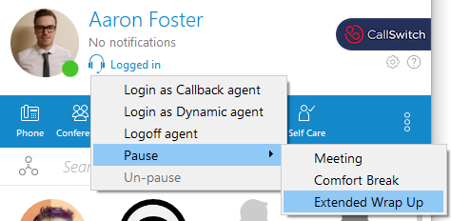
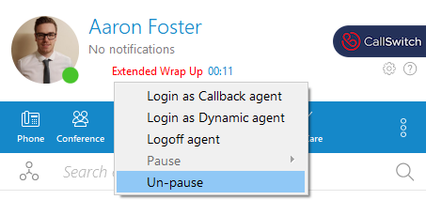
Agent Panel:
Pressing the "Agent Panel" button will open the agent panel, this view will show the agent live stats of the queues they are a member i.e. the amount of active calls queuing, it will also show the status of the other agents assigned to these queues and can be useful for managing workflow.
Queues & Agents that are visible here can be configured in the agent panel settings.
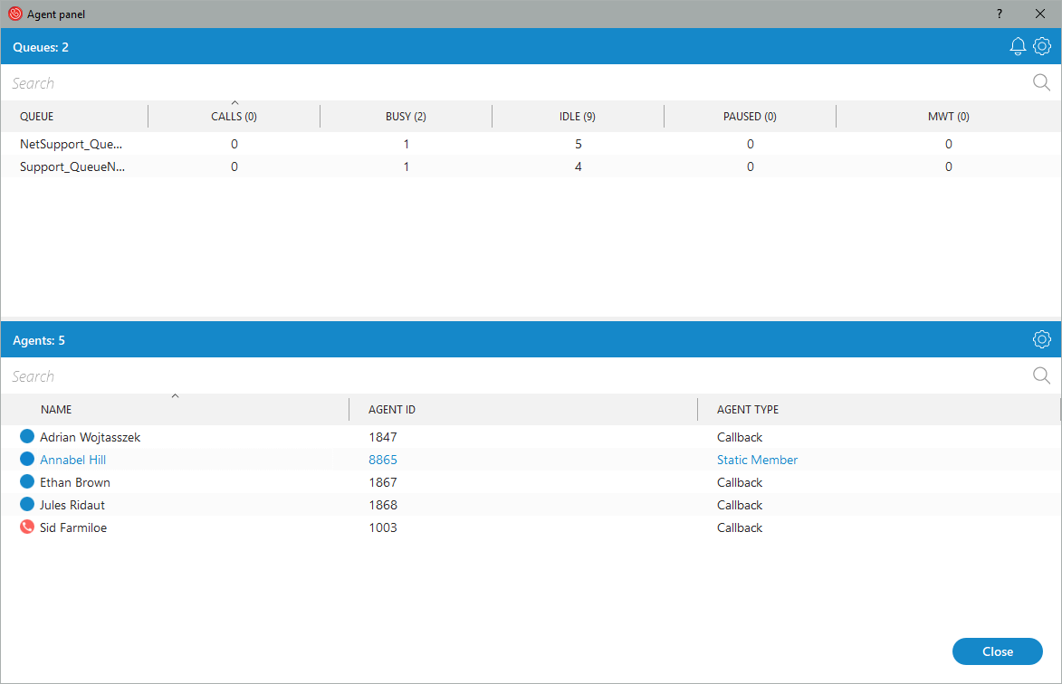
The agent panel can also alert agents of caller wait time, this Alert parameter can be configured by pressing the gear symbol in the corner of the window. By default this is set to 7 minutes, but can be customised on a per client basis.
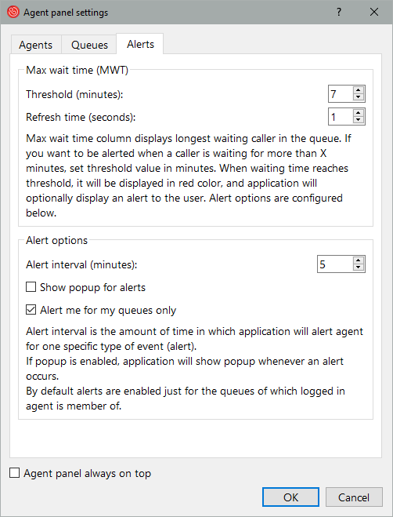

From the Agent Panel an agent can also start a call or message chat with another agent by right clicking on that agent.
