How to factory reset a Yealink T58 telephone

Press and hold the REDIAL button ( see image below)

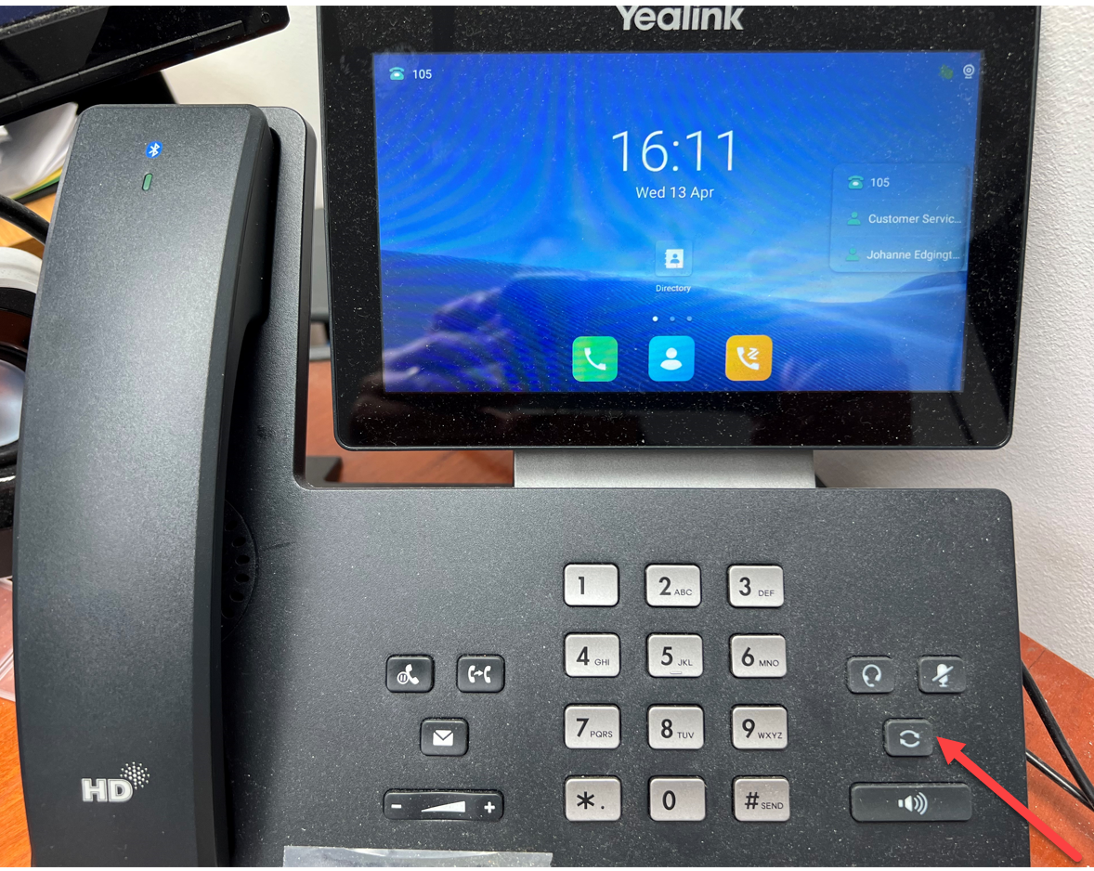

When you get the “reset to factory settings message” – Ok that (see below)
