Answer an incoming call on your CS1 mobile app and you get the following screen

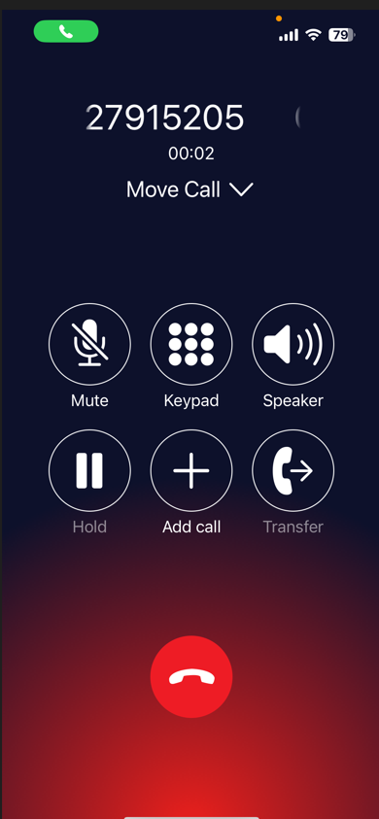
Click the “Transfer” button (do not put the call on hold first)
You will be presented with a list of internal contact and / or contacts on your mobile depending on what settings you have in place , screen as follows

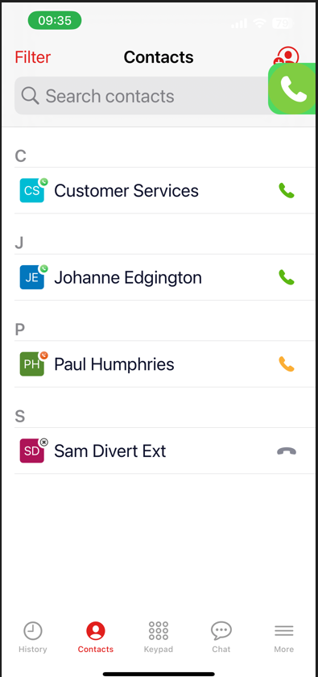
In this case we select Johanne Edgington and got the following screen with a list of options on how to connect the call

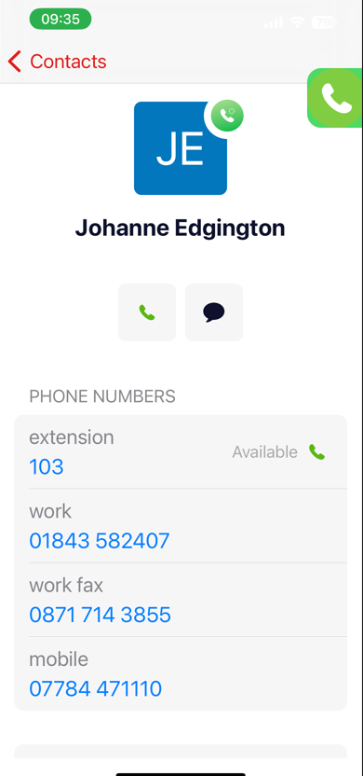

We selected the internal extension 103 and got the next screen

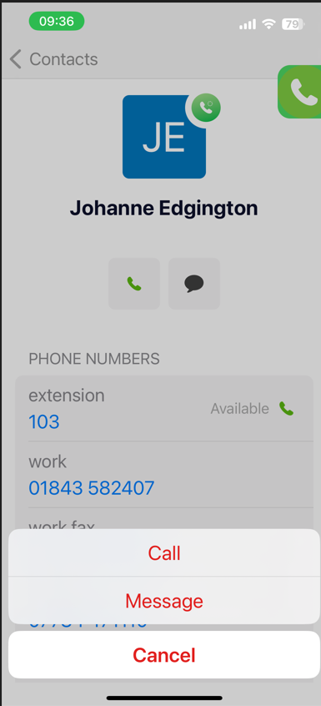

We selected CALL and got the next screen

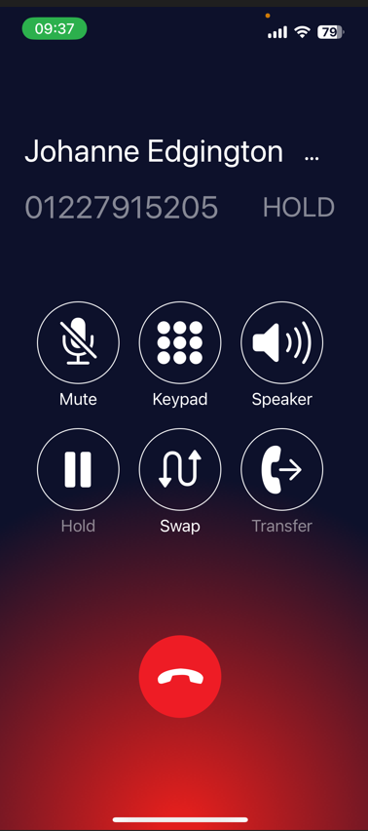

Johanne answered , we announced the call and then pressed Transfer again, and the call was transferred to Johanne

